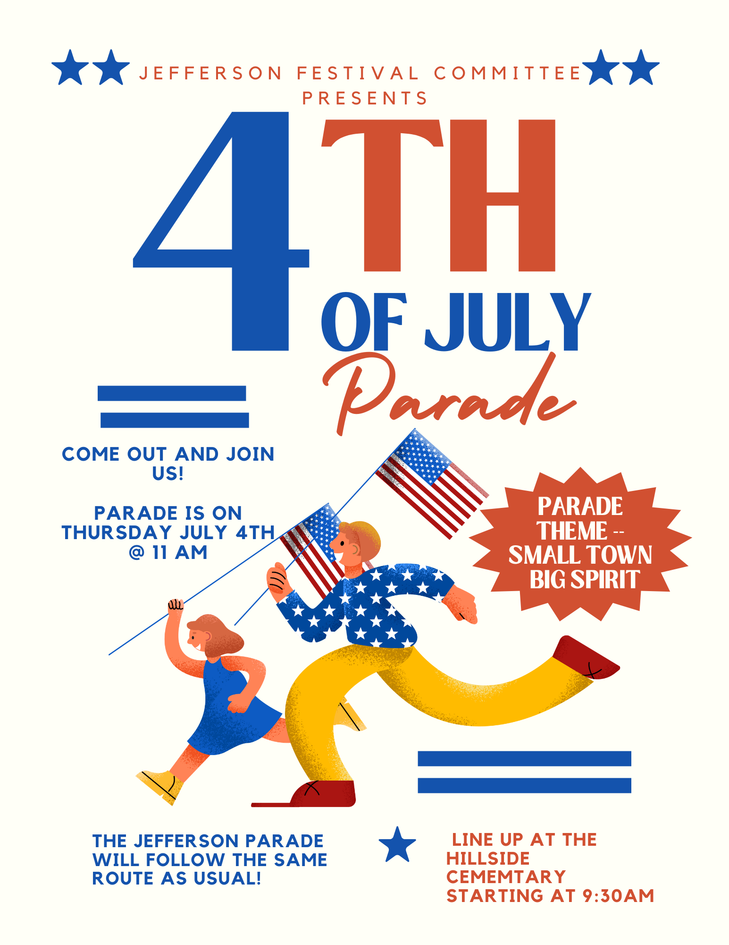

For further information, please contact the Jefferson Festival Committee at our email: Jeffersonfestivalcommittee@gmail.com

REGISTRATION INFORMATION

NAME:
ADDRESS:
EMAIL: PHONE:
DESCRIPTION OF ENTRY :
ITEMS TO BE THROWN OUT ALONG THE ROUTE :
Acknowledgement of Risk & Hazards Liability Release & Agreement Not to Sue
- I understand that my involvement in the Jefferson 4th of July Parade may pose certain risks to myself as well as to other vendors or attendees of the event. I understand that having a Jefferson Festival Committee (JFC) member present does not lessen the amount of severity of the risks of these activities. I understand that the JFC is not responsible for my safety. I agree and assume all responsibility for actions and omissions, and for all property that I may bring to the Town of Jefferson Premises. I also understand and agree that I am solely responsible for any products or items I may display or sell as well as any equipment I may bring or have on the Town of Jefferson premises.
- I hereby freely and expressly assume and accept the responsibility for any and all risks of injury or death while participating in these activities or related activities while present on the Town of Jefferson premises. I agree to RELEASE, FOREVER DISCHARGE, INDEMNIFY, DEFEND, and HOLD HARMLESS the Jefferson Festival Committee its directors, officers, members landowners, the Town of Jefferson and all the event sponsors (hereinafter “Releasees”) from any and all losses, damages, costs and attorney’s fees resulting from any and all claims or suits for personal injury, death and/or property damage that may in any way arise out of my participation in these activities or related activities.
- I AGREE TO RELEASE, FOREVER DISCHARGE, INDEMNIFY, DEFEND, AND HOLD HARMLESS THE RELEASEES FROM ANY AND ALL CLAIMS, SUITS, COSTS, AND ATTORNEY’S FEES FOR DAMAGE AND PERSONAL INJURY TO ME OR MY PROPERTY RESULTING FROM THE NEGLIGENT ACTS OR OMISSIONS OF THE RELEASEES. I UNDERSTAND THAT THE RELEASEES ARE NOT RESPONSIBLE FOR THE CONSEQUENCES OF THEIR OWN NEGLIGENCE, THAT IS THEIR FAILURE TO USE REASONABLE CARE IN ANY WAY.
PARTICIPANT SIGNATURE: DATE:
Please read and initial each item
Participants are responsible for all parts of their entry to the parade
Hosts are not responsible for participant’s property
Hosts reserve the right to decline duplicate participants
All participants are responsible for set up & removal of all parts of their entry
Participation is not reserved until we receive your registration form
We reserve the right to market your entry before/during/after the event to include social media and photos (we use a photo taken during the parade to advertise for our next one)

